QUESTION : 1
Create a CTE using the WITH clause to select all products with a rating above 4.5 from a 'Products' table, similar to how Flipkart or Myntra might highlight top-rated items :

TABLE Products :
CREATE TABLE Products(
product_id INT,
product_name VARCHAR(100),
category VARCHAR(50),
rating DECIMAL(2,1),
price INT,
PRIMARY KEY(product_id)
);

VALUES :
INSERT INTO Products (product_id,product_name,category,rating,price)
VALUES
(1,'laptop','electronics',4.8,65000),
(2,'shoes','fashion',4.2,2500),
(3,'watch','accessories',4.9,5000),
(4,'headphones','electronics',4.6,3000),
(5,'bag','fashion',4.1,1200);
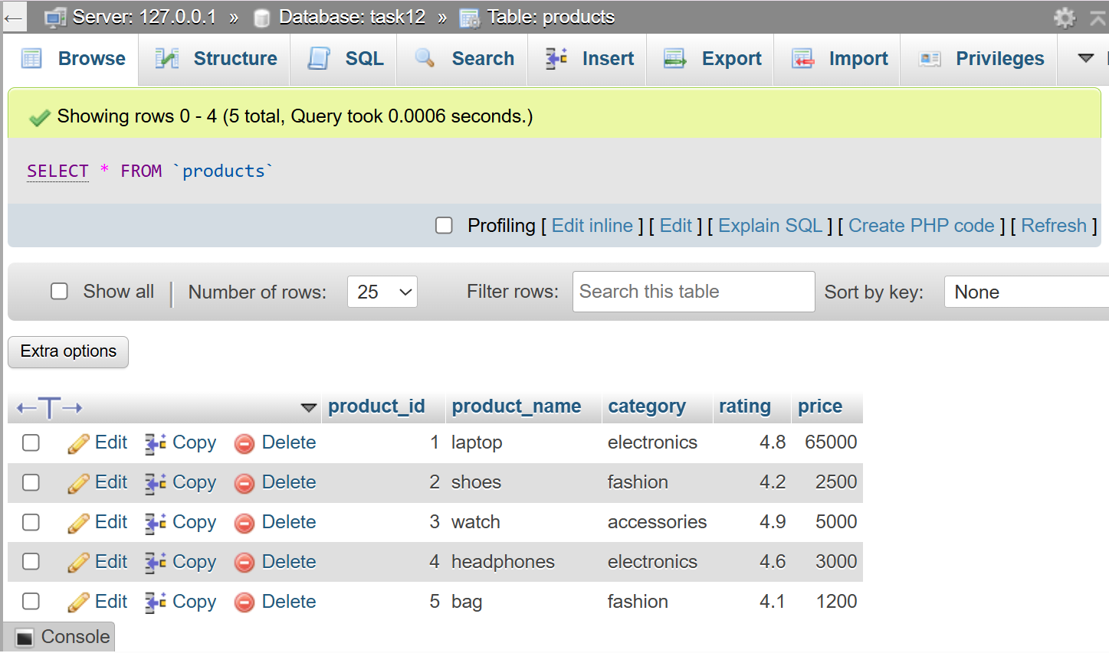
WITH TopProducts AS
(SELECT * FROM Products WHERE rating > 4.5)
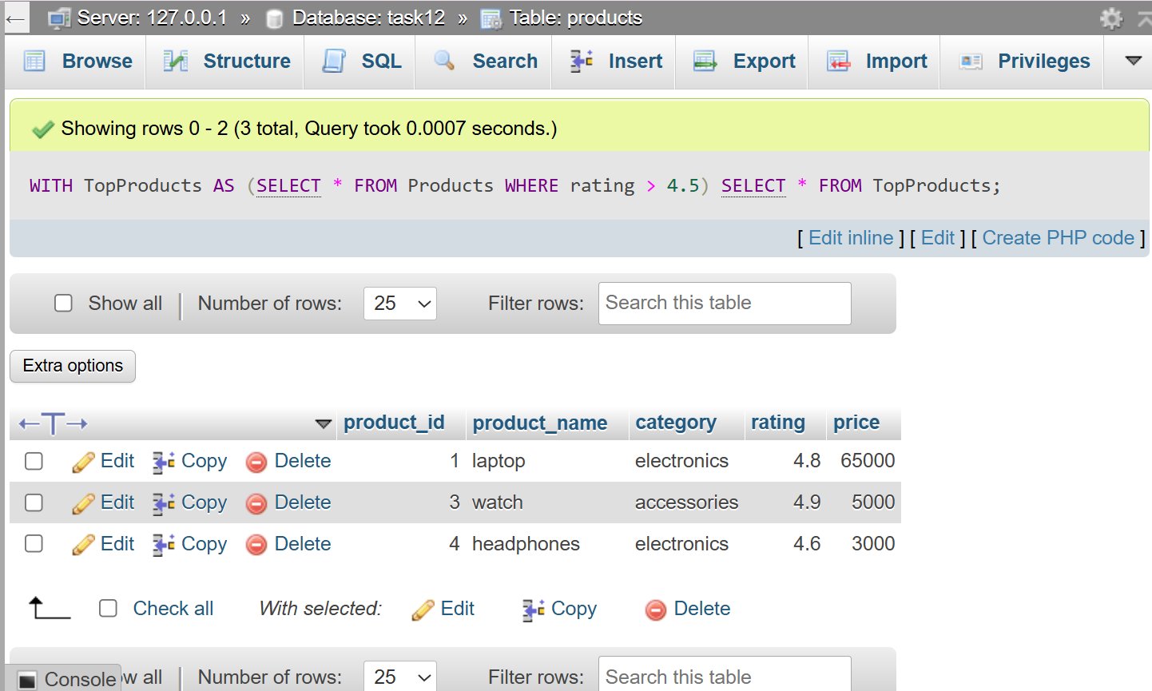
SELECT * FROM TopProducts;
QUESTION : 2
Rewrite a query that finds all restaurants in 'Ahmedabad' with delivery charges under 50 from a 'Restaurants' table, first using a subquery and then using a CTE. Compare both queries for readability.<br><br><em><strong>Hint:</strong> Focus on making the CTE version cleaner and easier to understand.</em> :

TABLE Restaurants:
CREATE TABLE Restaurants(
id INT,
name VARCHAR(100),
city VARCHAR(50),
delivery_charge INT,
rating DECIMAL(2,1),
PRIMARY KEY(id)
);

VALUES :
INSERT INTO Restaurants (id,name,city,delivery_charge,rating)
VALUES
(1,'Dominos','Ahmedabad',40,4.5),
(2,'McDonalds','Ahmedabad',60,4.2),
(3,'La Pinoz','Ahmedabad',30,4.8),
(4,'Honest','Surat',40,4.4),
(5,'Pizza Hut','Ahmedabad',45,4.3);
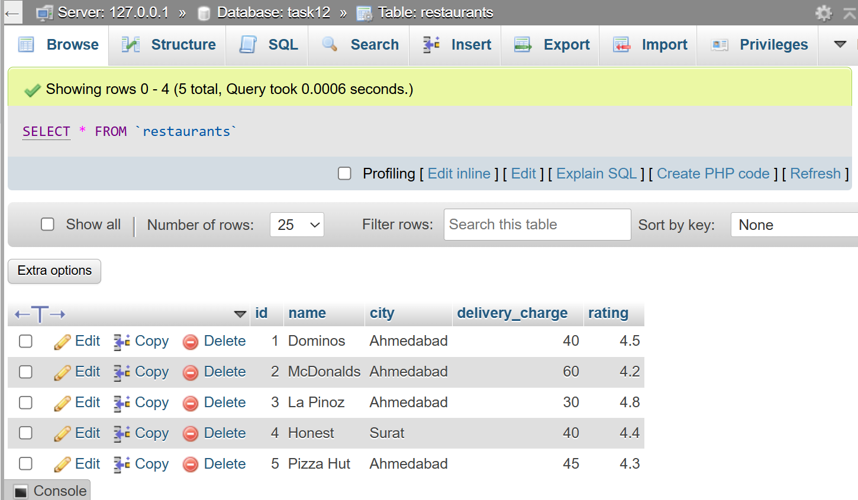
USING SUBQUERY :
SELECT * FROM
(SELECT * FROM Restaurants WHERE city='Ahmedabad') AS R
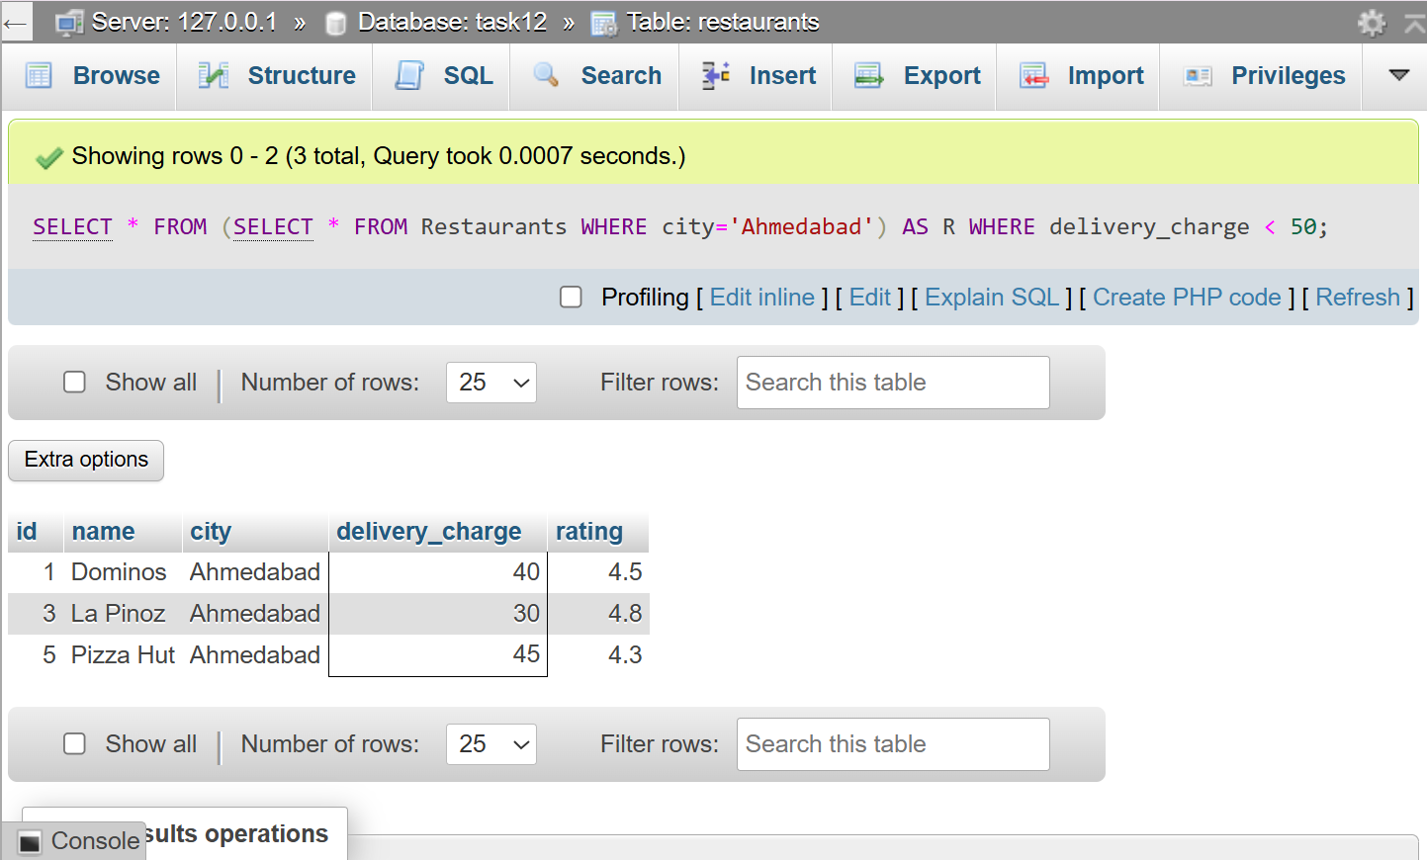
WHERE delivery_charge < 50;
USING CTE:
WITH Ahmedrest AS
(SELECT * FROM Restaurants WHERE city='Ahmedabad')
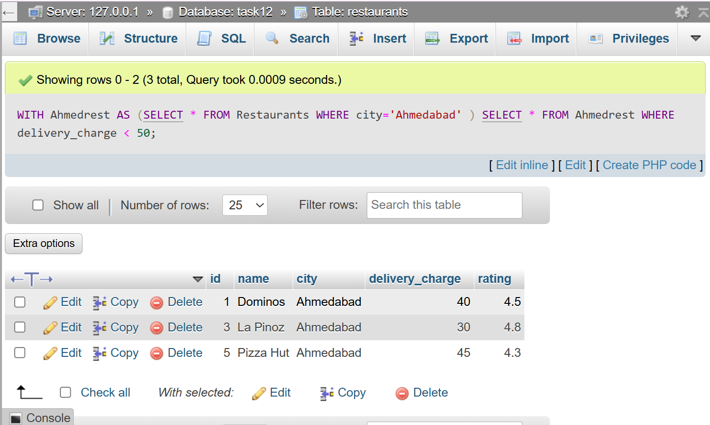
SELECT * FROM Ahmedrest WHERE delivery_charge < 50;

QUESTION : 3
Using two CTEs in a single query, find the top 3 most-followed users and the top 3 most-liked posts from a 'Users' and 'Posts' table (think Instagram-style data). Output both lists in the same result set :

TABLE Users :
CREATE TABLE Users(
user_id INT,
user_name VARCHAR(100),
followers INT,
PRIMARY KEY(user_id)
);
INSERT INTO Users VALUES
(1,'Vivek',1200),
(2,'Rahul',3500),
(3,'Priya',2800),
(4,'Amit',5000),
(5,'Neha',1800);
TABLE Posts :
CREATE TABLE Posts(
post_id INT,
post_title VARCHAR(100),
likes_count INT,
PRIMARY KEY(post_id)
);
INSERT INTO Posts VALUES
(1,'Travel',400),
(2,'Food',1500),
(3,'Coding',900),
(4,'Fitness',2500),
(5,'Nature',1800);

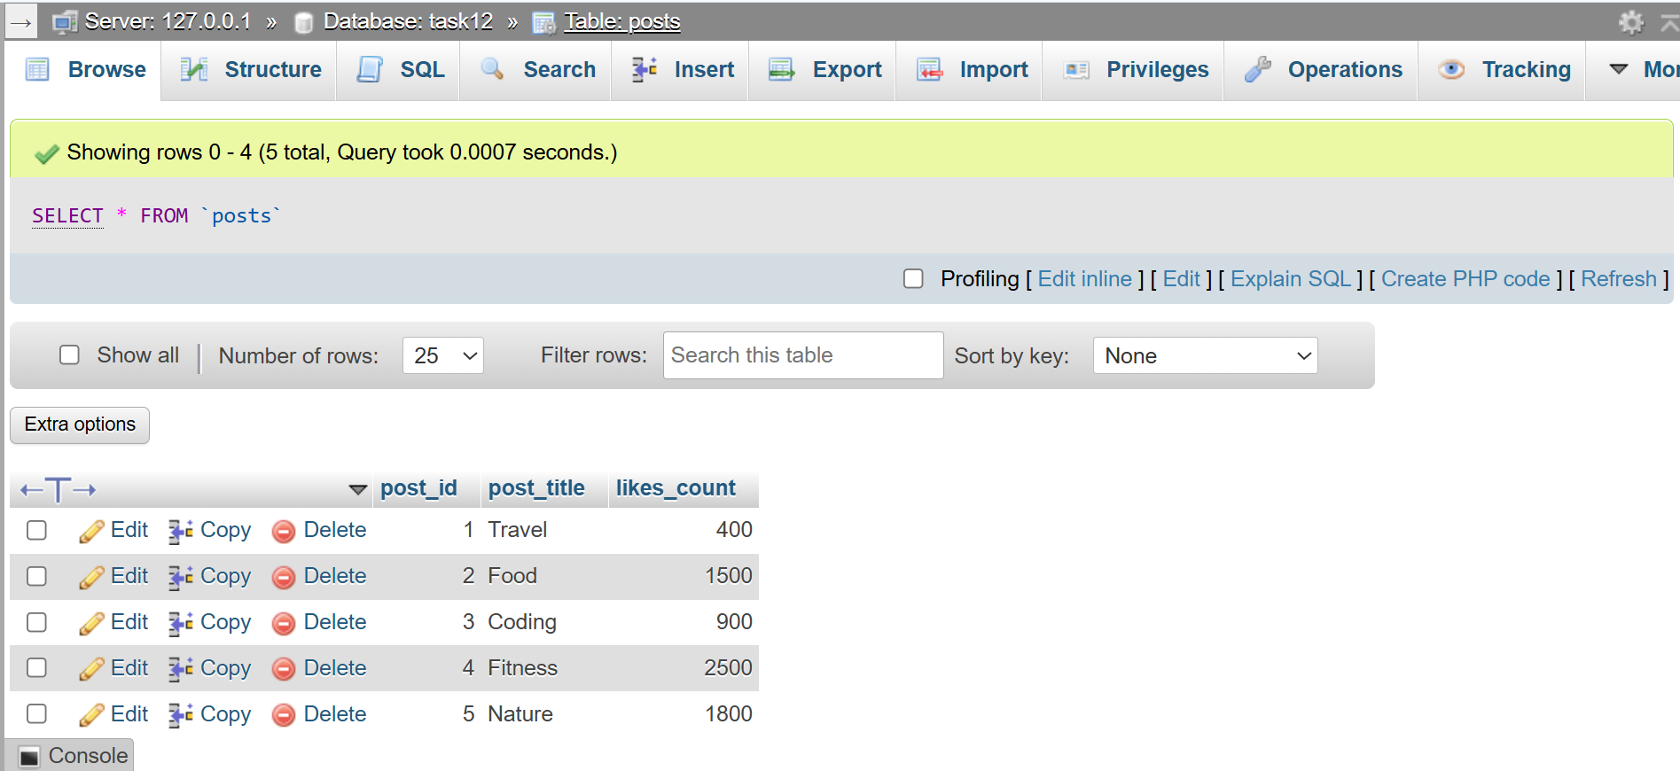
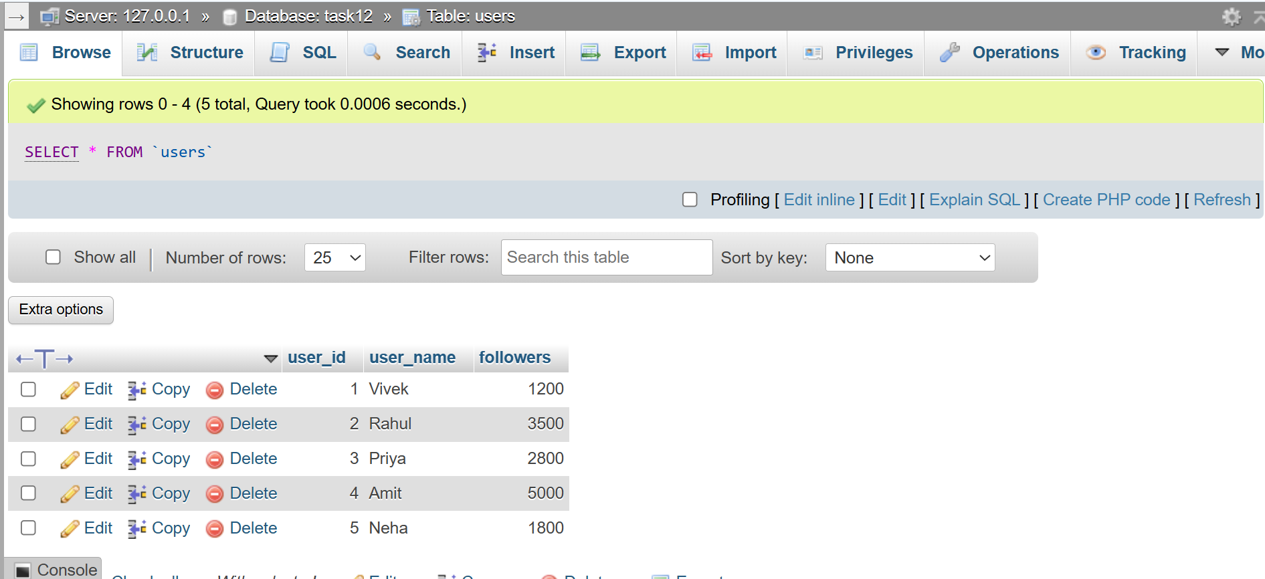
WITH TopUsers AS
(SELECT user_name,followers FROM Users
ORDER BY followers DESC LIMIT 3),
TopPosts AS
(SELECT post_title,likes_count FROM Posts
ORDER BY likes_count DESC LIMIT 3)
SELECT 'Top User' AS Type,user_name AS Name,followers AS Count FROM TopUsers
UNION ALL
SELECT 'Top Post' AS Type,post_title AS Name,likes_count AS Count FROM TopPosts ;
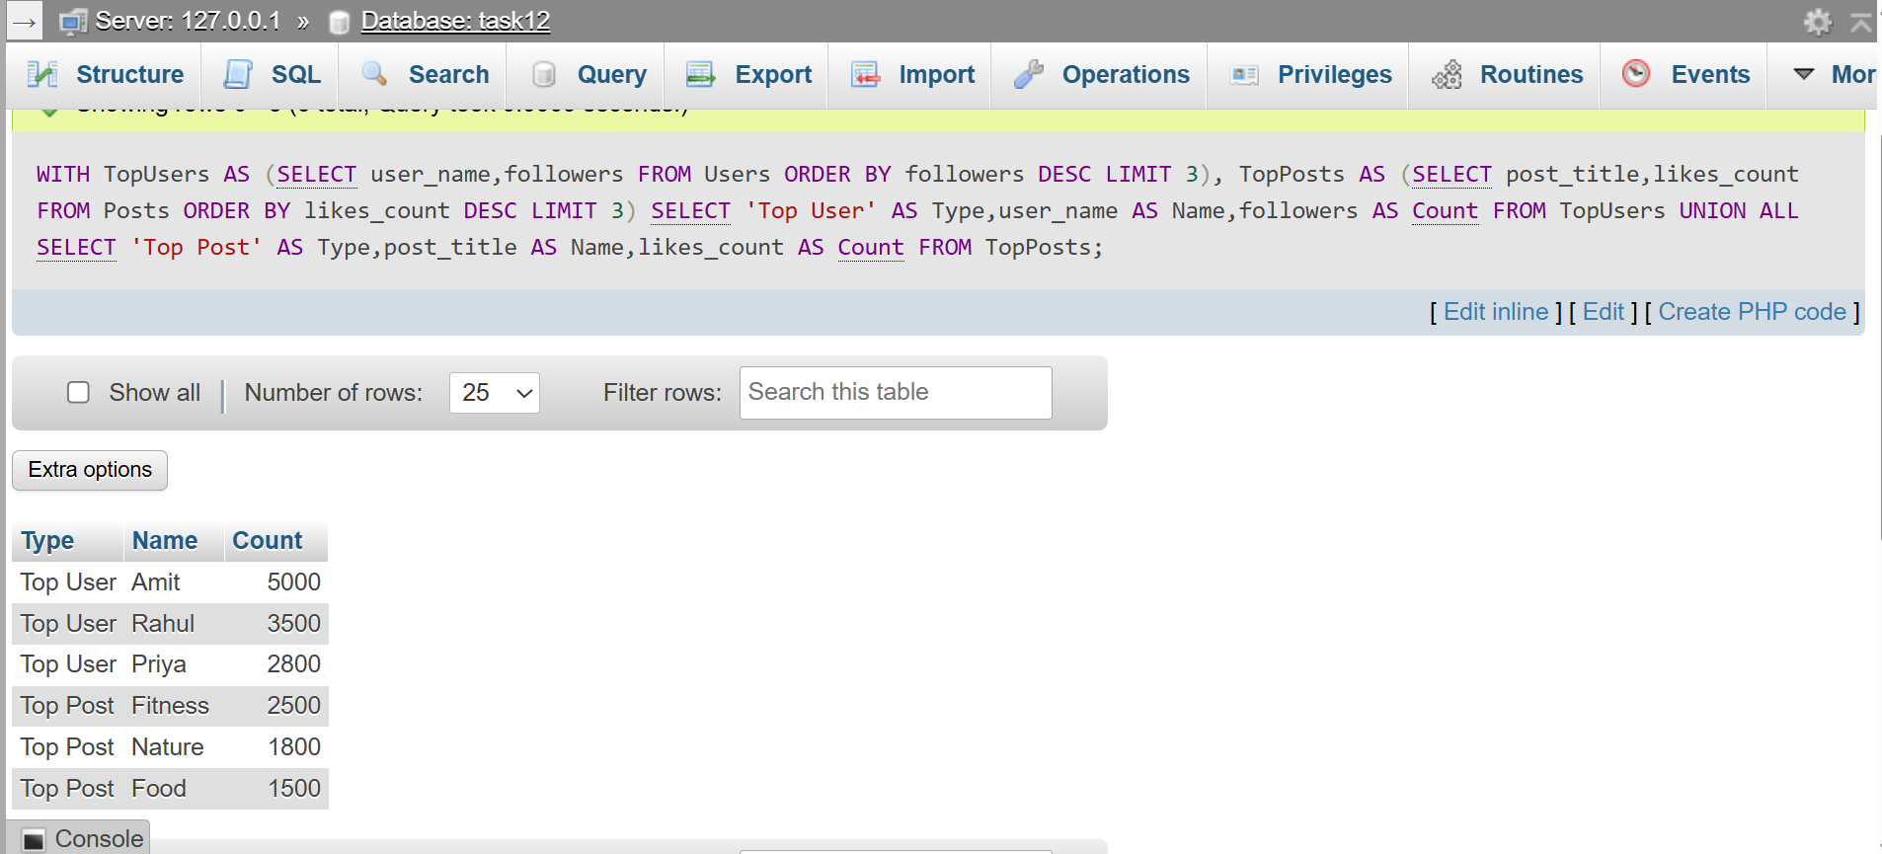

QUESTION : 4
Write a recursive CTE that generates a list of dates for the next 7 days starting from today, similar to how BookMyShow shows available dates for movie bookings.<br><br><em><strong>Hint:</strong> Use a base case for today and recursion to add one day at a time.</em> :

WITH RECURSIVE Next7Days AS
(
SELECT CURDATE() AS DateValue
UNION ALL
SELECT DATE_ADD(DateValue, INTERVAL 1 DAY) FROM Next7Days
WHERE DateValue < DATE_ADD(CURDATE(), INTERVAL 6 DAY)
)
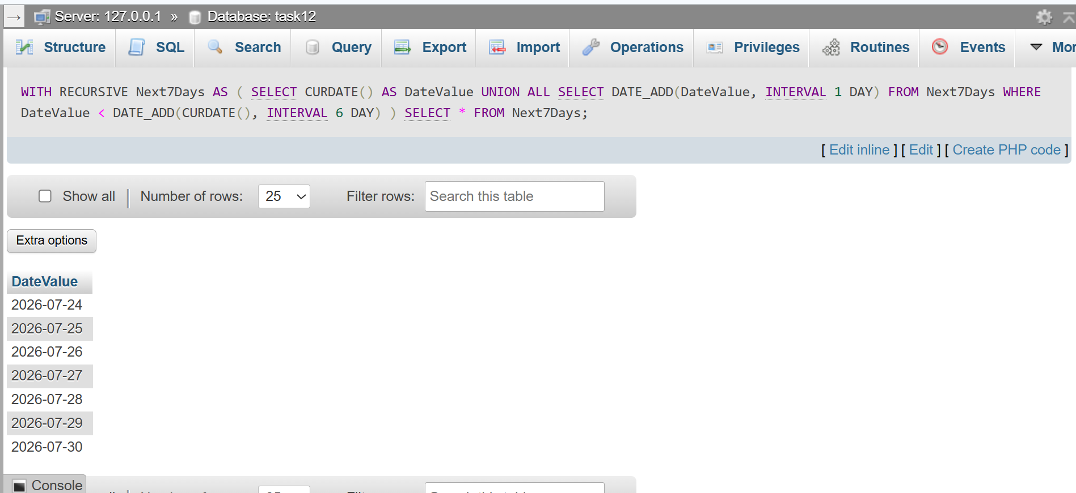
SELECT * FROM Next7Days ;
QUESTION : 5
Given a messy SQL query that finds all users with more than 1000 followers from a 'Users' table, refactor it to use a CTE for better clarity and maintainability :
TABLE Userss :
CREATE TABLE Userss (
user_id INT,
user_name VARCHAR(100),
followers INT,
PRIMARY KEY(user_id)
);
INSERT INTO Users (user_id,user_name,followers)
VALUES
(1,'Vivek',1200),
(2,'Rahul',3500),
(3,'Priya',2800),
(4,'Amit',5000),
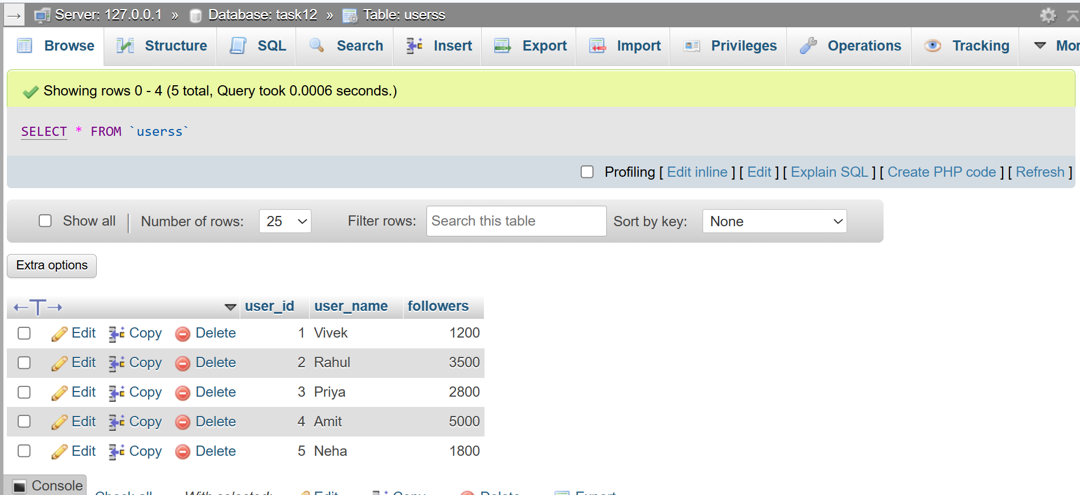
(5,'Neha',1800);
Query (Without CTE) :
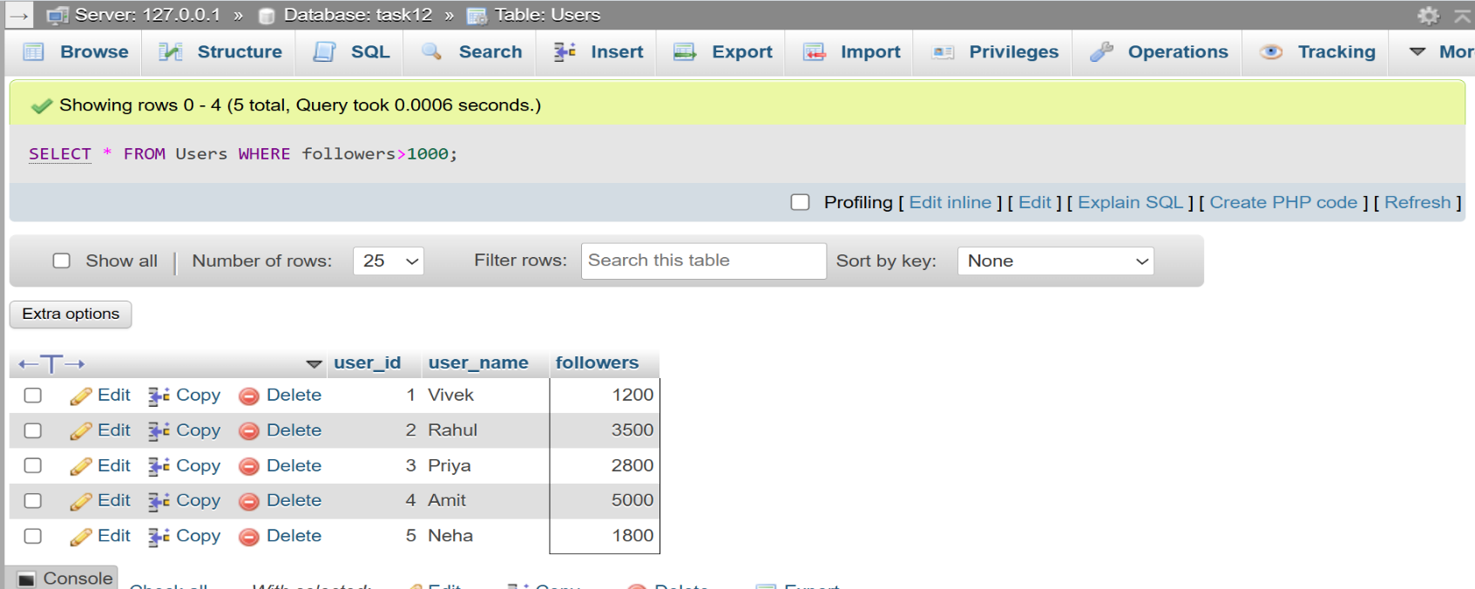
SELECT * FROM Users WHERE followers>1000 ;
Query Using CTE :
WITH PopularUsers AS
(SELECT user_id,user_name,followers
FROM Users WHERE followers > 1000)
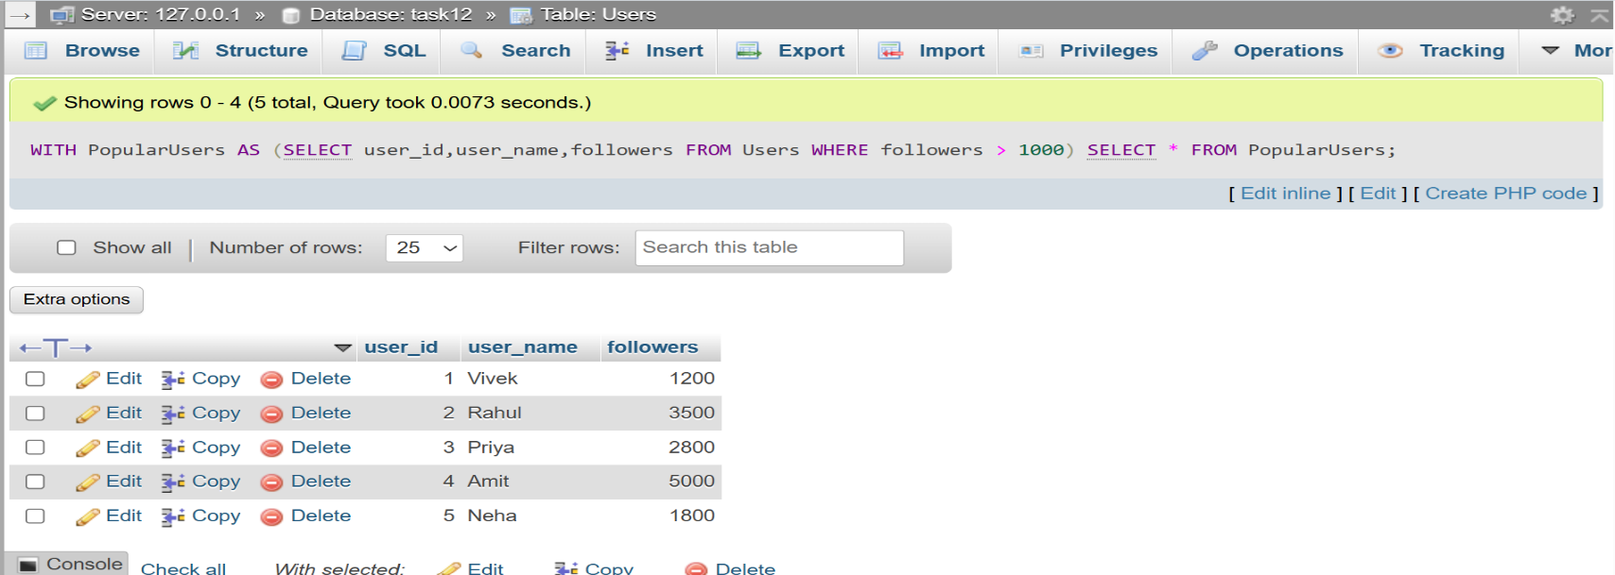
SELECT * FROM PopularUsers ;
The CTE version improves readability and makes the query easier to maintain…..

